Practical 8

**Aim:** To install MySQL server to configure database server and install phpMyAdmin to operate MySQL on web browser from clients**.**

**Step 1:** First step would be to install MySQL server and configure it.

sudo apt-get install mysql-server-5.7

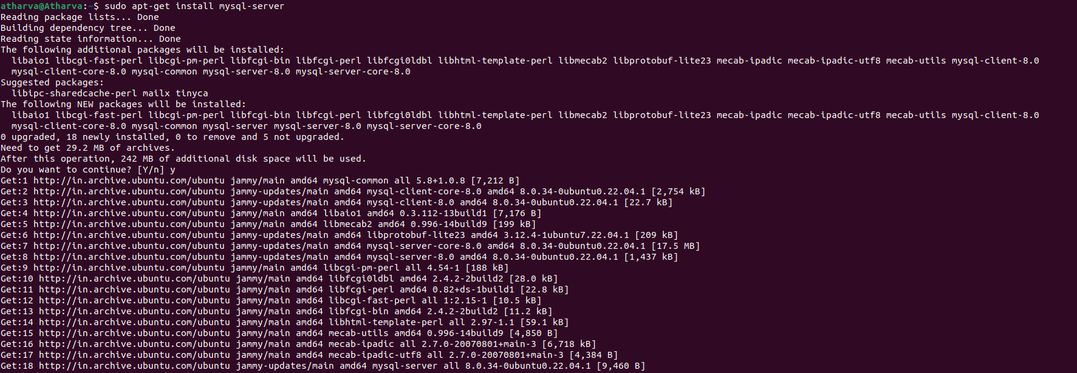

**Step 2:** Once the MySQL server installation is done you can connect to it by opening it

mysql -u root p

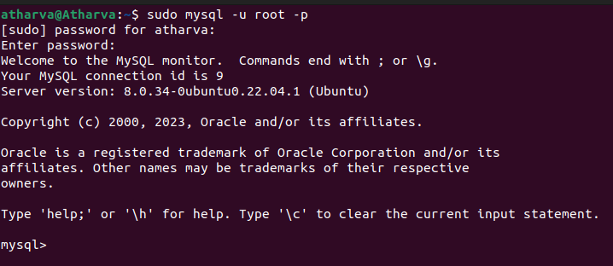

**Step 3:** Now we will display the user info and also the ip for our host by using the following command.

select user, host from mysql.user;

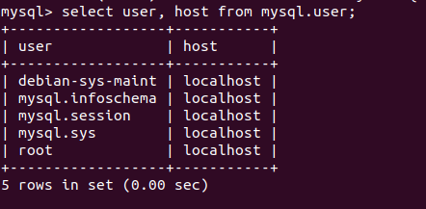

SHOW VARIABLES WHERE Variable_name='port';

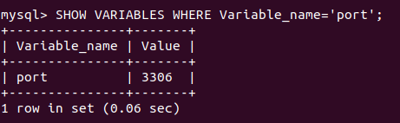

Exit the mysql prompt using 'exit' command.



**Step 4:** Now let's install phpMyAdmin so that we can operate MySQL on web browser from clients.

sudo apt-get install phpMyAdmin

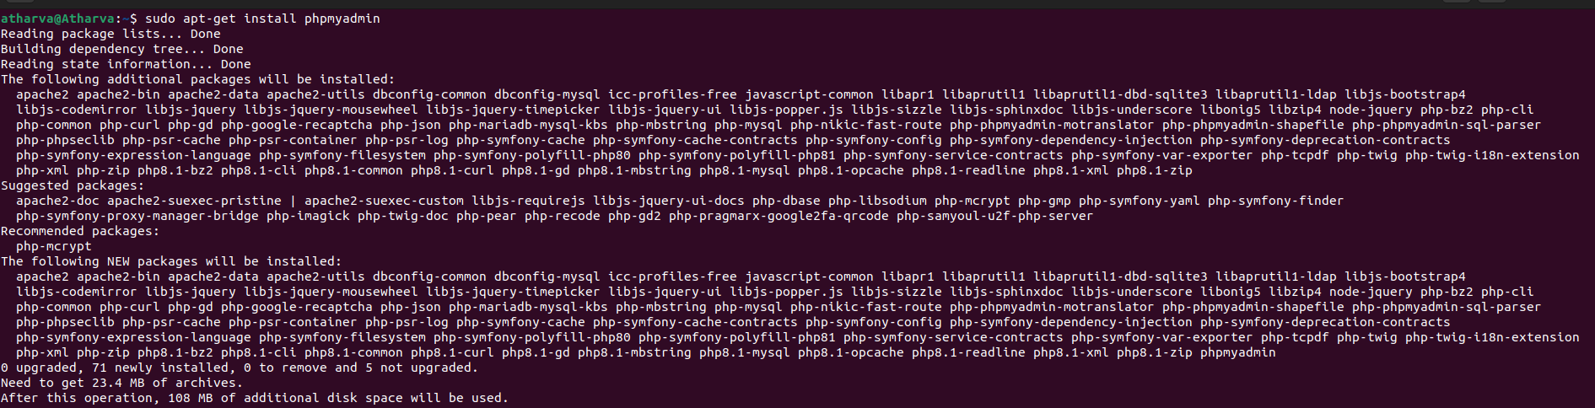

During intsallation you'll be asked which web server you want to configure to run phpMyAdmin.

Select "apache2"

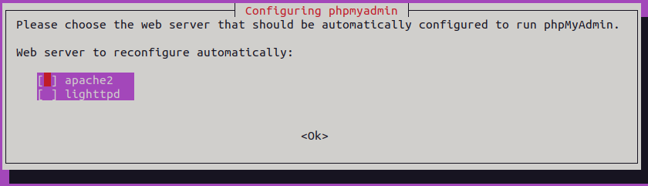

After that you'll be asked that if you want dbconfig-common for your phpMyAdmin, select yes and proceed.

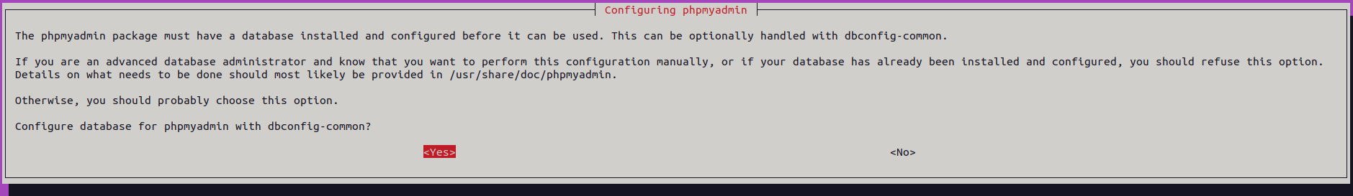

Now set the password for phpmyadmin.

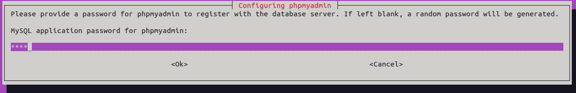

**Step 5:** Now we have to edit the apache file and set the required ip for our server.

sudo nano /etc/phpmyadmin/apache.conf

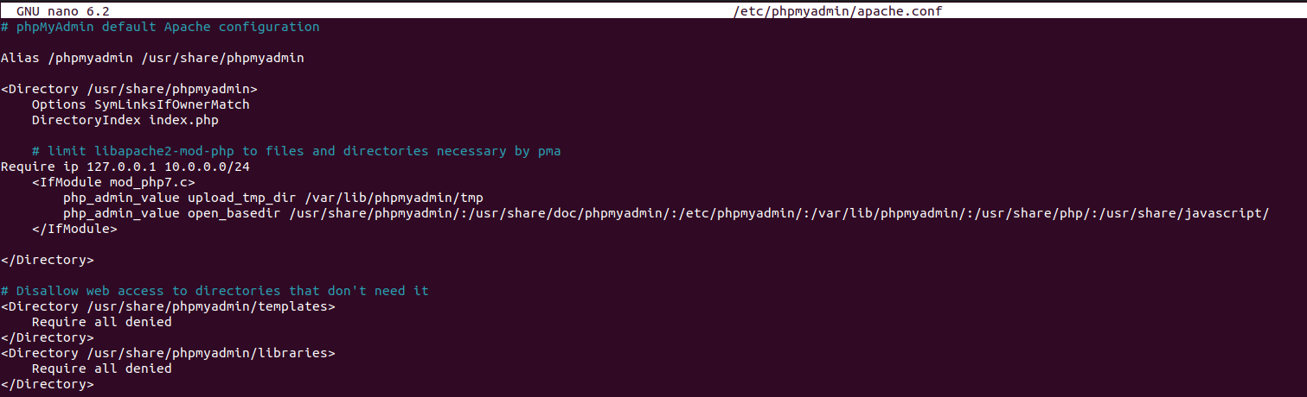

**Step 6:** Now restart the apache server which can be done using the following command.

sudo /etc/init.d/apache2 restart

